SS8H8 Analyze Georgia’s participation in important events that occurred from World War I
through the Great Depression.
Initially, Georgians were rather indifferent to the events of World War I. The assassination of Archduke Franz Ferdinand, the sinking of the Lusitania, and the interception of the Zimmerman Telegram caused little concern for many Georgians. However, when the United States entered World War I on April 6, 1917, war sentiment shifted to one of panic and suspicion. Georgia provided more military training camps for the war effort than any other state. After the war, Americans celebrated the victory throughout the nation. In this era, known as the “Roaring 20s” many Americans listened to jazz, danced the Charleston, and invested and hit it big in the stock market. However, these good times were not happening for most Georgians. Primarily a rural state, Georgia, was suffering though one of the worst droughts in its history. Additionally, a tiny insect called the boll weevil was devastating Georgia’s most important crop: cotton. While Georgia was suffering through a “mini-depression” during the 1920s, after the stock market crash of 1929, America’s Great Depression hit the nation with devastating outcomes throughout the next decade. Georgia, already suffering from the effects of the drought and boll weevil, experienced more hard times during the Great Depression. In 1933, part-time Georgia resident Franklin Roosevelt became president. President Roosevelt and his “brain trust” developed several “New Deal” programs that directly affected Georgia. However, Georgia’s governor, Eugene Talmadge, was against the interference of the federal government in state policies and fought against the New Deal programs. Interestingly, both Roosevelt and Talmadge, though on opposite ends of the political spectrum, were popular among Georgians and the voters of the state helped elect them in their respective positions for four terms.
SS8H8 Analyze Georgia’s participation in important events that occurred from World War I
through the Great Depression.
b. Explain economic factors that resulted in the Great Depression (e.g., boll weevil and drought).

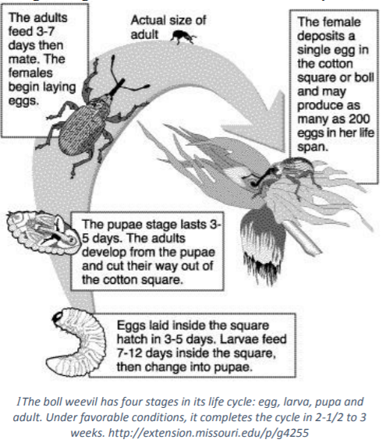
Georgia experienced an agricultural economic downturn in the years prior to the Great Depression. The invasion of the boll weevil and serious droughts caused farmers to be launched into serious loss of income and the need to examine agricultural practices. The boll weevil is an insect whose larva feeds on the cotton plant. While the pest is thought to have originated in Central America, by the 1890s it had made its way into Mexico and then into Texas. By 1915 it had migrated to Georgia and drastically reduced the state’s cotton crop. Due to the destruction caused by the boll weevil, Georgia cotton farmers went from producing “5.2 million acres of cotton in 1914 to 2.6 million acres in 1923.” The boll weevil had a huge impact on Georgia’s economy and rural population. Due to the loss of cotton acreage, along with the recruitment of northern companies, millions of African-Americans or Blacks moved to northern cities. In addition, many sharecroppers and tenant farmers, both Black and white left the farms and moved to Georgia cities such as Atlanta and Macon or migrated into northern cities in search of employment. Cotton ceased to be Georgia’s primary agricultural product. Also, with the population movement into the cities, Georgia’s manufacturing continued to develop, though slowed greatly by the Great Depression. In addition to the damage caused by the boll weevil, Georgia farmers suffered through another natural disaster in the 1920’s and 1930’s: a drought. The worst droughts in Georgia history were from 1924-1927 and 1930-1935. With the damage caused by the boll weevil and the droughts, Georgia began to suffer from a depression long before the rest of the United States, the economic boom experienced by the rest of the United States ended with the Stock Market Crash of 1929. In this downturn, stock-holders lost over 40 billion dollars, and businesses were never able to recover from these losses throughout the 1930’s. However, a series of other factors led to the continuation of a world-wide depression for almost a decade.

Some of the other economic factors that led to the Great Depression were:

• Bank Failures: During the 1920’s and 1930’s, there was no insurance protecting deposits. If enough of the banks customers tried to withdraw their money, the bank would eventually run out. This was called a bank failure.
• Reduction in Purchasing: the average consumer stopped purchasing goods. When people stopped buying products, companies in turn lowered their production rates. With lower production rates, many consumers lost their jobs and had no money to spend.
• Overproduction of Agriculture Products: Before the major droughts that hit the Midwest causing the Dust Bowl, many farmers over-produced. This over-production led to a tremendous drop in the price of agricultural products and dramatically limited the profit for farmers. During a period of time where millions were starving, farmers destroyed much needed food or stopped growing crops all together in order attempt to raise the price of agricultural products. A major drought hit the Midwest in the 1930’s driving thousands of farmers from their homes and added to the millions of Americans already out of work.

SS8H8 Analyze Georgia’s participation in important events that occurred from World War I
through the Great Depression.
e. Examine the effects of the New Deal in terms of the impact of the Civilian Conservation Corps, Agricultural Adjustment Act, Rural Electrification Administration, and Social Security
Administration.

Though Georgia voters supported Governor Eugene Talmadge, a critic of the New Deal, in several elections, Georgians also overwhelmingly supported President Franklin Roosevelt and his New Deal programs throughout the Great Depression. The New Deal Programs provided aid and support to many poor Georgians. Though these programs did not end the Great Depression, they helped many poor Georgians cope during the difficult economic times.

These New Deal Programs significantly impacted Georgia during the Great Depression:

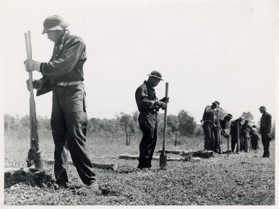
• The Civilian Conservation Corps (CCC) 1933-1942 One of the New Deal programs that had a major impact on the state was the Civilian Conservation Corps (CCC). The purpose of the program was to hire unemployed young men to work on public service projects. Some of these projects included erosion control, flood prevention, and public parks. Of all of the New Deal programs, this was probably the most successful and popular. Over the nine years it was in existence, over 3 million young men worked in the program and planted millions of trees throughout the country. However, once the U.S. entered World War II, these men changed out of their CCC uniforms and into military ones. In 1942, the CCC was disbanded. In Georgia, the CCC had a lasting impact. Over “78,000 Georgians were employed by the CCC” and these men planted over 22 million trees and built or improved several state parks. These parks are still used today, including historic battle fields such as Chickamauga and Kennesaw Mountain. Segregation was incorporated in these federal groups. For example, an all-black CCC unit helped to develop the infrastructure of the Okefenokee Wildlife Refuge.

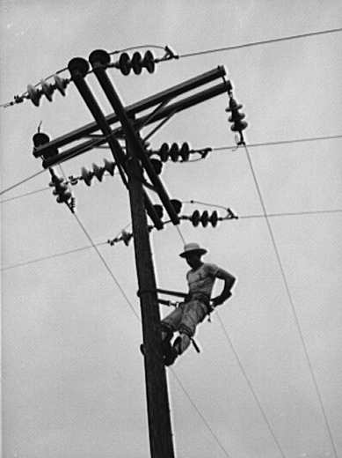
• Rural Electrification Administration (REA) 1936 It is often said that while Roosevelt was staying at his home “the Little White House” in Warm Springs, GA, he was shocked at the cost of his electric bill. According to the story, Roosevelt claimed that he paid less at his large home in New York than he did for his small home in Georgia. Whether this story is true or not, Roosevelt had an interest in bringing electricity to all parts of the country. In 1935 the Rural Electrification Administration was established by presidential Executive Order 7037 to do just that. Though many members of Congress and state governors, such as Georgia’s Eugene Talmadge, fought against this program, fearing it would lead to socialism, many farmers benefited from it. The Rural Electrification Act was passed by Congress in 1936. According to the New Deal Network, by 1939 there was a 25% increase in the number of rural households that had electricity, and for a reasonable price. If they could afford it, many farmers bought appliances that used electricity which helped stimulate the economy. Since Georgia was a rural state during this time period, many Georgians also benefited from the program.

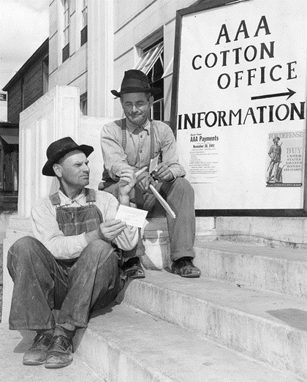
• The Agricultural Adjustment Act (AAA) 1933
One of the New Deal programs to have a lasting effect on Georgia was the Agricultural Adjustment Act (AAA). The basic premise of the AAA was that, since so many farmers continued to grow crops such as cotton and tobacco during the Depression which drove the prices of these products down, the federal government offered to pay farmers not to grow those crops. This caused the price of agriculture products to rise which helped famers make more money and eliminate surplus production. Yet, in many cases, this policy did more harm than good for sharecroppers and tenant farmers. Though the government told the landowner that the payments should be distributed to those who lived on and worked the land, many landowners simply kept the money for themselves. The government could not enforce this rule and, as a result, many of the people who needed this aid never received it. Often, since the sharecropper or tenant farmer could not work the land, they were simply removed. This was one of the factors that led to urbanization and the end of sharecropping and tenant farming in the state.

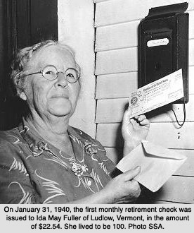
• Social Security Administration (SSA) 1935 Another program that had a lasting effect on Georgia was the Social Security Administration (SSA). Until 1935, those who were too old or unable to work were dependent on the charity of others. The Social Security Administration offers benefits for those over 65, those who are disabled, or those who are the survivors of a beneficiary who has died. This program is one of the longest running of the New Deal, and today most Georgians are connected to the SSA either through paying social security taxes or receiving social security benefits.

