SS8H7 Evaluate key political, social, and economic changes that occurred in Georgia during the New South Era.
The years between 1877 and 1918 were a time of both great social and economic successes and failures in Georgia’s history. After the Civil War and Reconstruction period, Atlanta began its “rise from the ashes” and slowly became one of the more important cities in the South, proving it by hosting events such as the International Cotton Exposition. Henry Grady, began to champion the cause of the “New South,” one that was industrial and self-sufficient. Entrepreneurs, both black and white, developed new services and products. Unfortunately, the “New South Era” was also a time of terrible racism and injustice. Segregation and “Jim Crow” were the law of the land. The resurgence of the Ku Klux Klan (KKK) after the murder of Mary Phagan targeted not only blacks, but Jews, Catholics, and immigrants as well. Tom Watson, once a champion of the “common man,” both black and white, gained greater notoriety after he changed his position and became an ardent segregationist and anti-Semite. Additionally, Atlanta experienced the worst race riot in its history. During this period of racial strife, several successful African-American men became well known throughout the country for their work with civil rights. This group of men included educators W.E.B. Dubois and Booker T. Washington.
SS8H7 Evaluate key political, social, and economic changes that occurred in Georgia during
the New South Era.
a. Identify the ways individuals, groups, and events attempted to shape the New South; include the Bourbon Triumvirate, Henry Grady, International Cotton Expositions, and Tom Watson and the Populists.
The Bourbon Triumvirate was a group of three politicians (Joseph E. Brown, Alfred H. Colquitt, and John B. Gordon) who dominated Georgia politics for over 20 years. These men, who all had been key figures during the Civil War, rotated positions as governor and U.S. Senator from the 1870’s to 1890’s. They held a common interest in developing the railroad and mining industries in Georgia, serving the interests of those men who were part of the planter class, and instituting low taxes. In addition, all three of the men were white supremacists who supported and took advantage of the convict lease system (the system of leasing convicts to business owners who in turn would provide housing, food and clothing for the convicts). The power of the Bourbon Triumvirate disappeared as the ideals of the Populist Party and the New Democrats began to dominate the Democratic Party in 1890’s.

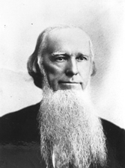
Joseph E. Brown (1821-1894) was born in South Carolina, attended Yale Law School and moved to Georgia where he became a successful lawyer. He was elected to the Georgia General Assembly in 1849 and became a state judge in 1855. Brown was a passionate secessionist before the war, and in 1857, he was elected governor of Georgia and remained in this position throughout the Civil War. He later switched his allegiance back to the Democratic Party and served in the U.S. Senate from 1880-1890.

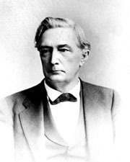
Alfred H. Colquitt (1824-1894) was born in Walton County, Georgia. He graduated from Princeton University in 1844 and returned to Georgia and became a lawyer. He became a member of the General Assembly in 1859. As a passionate secessionist, he joined the Confederate Army after Georgia seceded, and had a distinguished military career during the Civil War. After the war, Colquitt served as Georgia’s governor from 1876-1882 and as a U.S. Senator from 1883-1894.

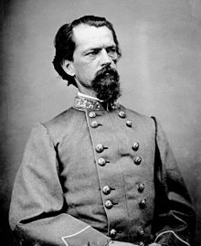
John B. Gordon (1832-1904) was born in Upson County, Georgia. After leaving the University of Georgia without graduating, he ended up managing his father’s coal mine before the start of the Civil War. Though receiving no military training, Gordon made his mark as a military strategist. Gordon fought in several important battles and rose to the rank of major general at the end of the war. After the war, Gordon returned to Georgia where he was an outspoken opponent of Reconstruction and is thought to have been the leader of the Georgia chapter of the Ku Klux Klan. Gordon was elected as a U.S. Senator in 1872 and served in this position until 1880. He resigned his position among scandal to head the Western and Atlantic Railroad. However, Gordon remained popular among white Georgians and was elected governor in 1886 and back to the U.S. Senate in 1891, serving until 1897.

Note: Historians have contended that the Bourbon Triumvirate was not a unified and cohesive unit that was written about and discussed in later years. The members had many different views about several issues and had a strong dislike for one another.
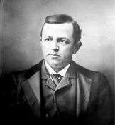
Henry Grady (1850-1889), born in Athens, GA, is best known for his continual campaign of the “New South.” As managing editor of the Atlanta Journal, Grady was able to use the newspaper to promote his views concerning the industrialization of the South, the diversification of southern agriculture, and to influence northern investors to financially help with both causes. Grady brought the International Cotton Expositions to Atlanta and created Georgia Institute of Technology (Georgia Tech). He was also active in local politics assisting in the elections of John B. Gordon and Joseph E. Brown. Grady also had his critics. He was often attacked by Populist Tom Watson and Georgia’s farmers for focusing on industry. Elected officials of Georgia’s other major cities such Athens, Augusta, and Macon, criticized Grady for his blatant bias in favor of Atlanta. Finally, many civil rights groups both in the North and South, were upset with his inaccurate description of racial relations in Georgia in order to bring in northern investors. Nevertheless, Grady, has been identified as the most important figure in the New South movement. Though he only lived to the age of 39, he had several important accomplishments in his short life time. Due to his achievements, Grady has been honored in several ways throughout the state including having a county named for him. Grady Hospital and the University of Georgia’s Grady School of Journalism are also named in his honor.

In 1881, 1885, and 1895, Atlanta was the site of three International Cotton Expositions. Primarily, the Cotton Expositions were established to promote Atlanta’s rebuilding from the Civil War, its industrial capabilities and accomplishments, and to bring northern investment into the city and region. The first two were heavily promoted by Henry Grady, but the most memorable was the exposition held in 1895. During the exposition of 1895, also known as the “Cotton States and International Exposition,” civil rights activist and educator, Booker T. Washington, gave his famous Atlanta Compromise Speech. This speech urged African-Americans to focus on economic improvement as opposed to political and social rights, an idea that was supported by white New South advocates, but not accepted by African- American leaders such as W.E.B. Dubois. All three of these events were effective in displaying Atlanta’s “rise from the ashes” and to establish it as the leading city of the New South.
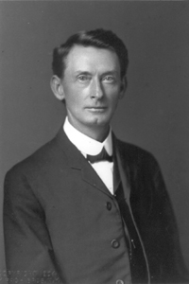
Tom Watson (1856-1922) was one of the most popular and most controversial figures in Georgia history. Born in Columbia County, his early career supported the poor tenant farmer and sharecropper of both races. When he was elected to the Georgia General Assembly in 1882, he supported the end to the convict lease system and was a supporter of public education for all Georgians. On a platform of lower taxes for the poor farmer, Watson was elected to the U.S. Congress. In Congress, Watson gained national notoriety for his leadership role in the passage of the Rural Free Delivery Act (the delivery of mail directly to rural farm families). In 1892, though supported by farmers of both races, he lost his reelection bid to Congress. Watson received the support of many rural black voters due to his disapproval of lynching. Because of his support for the Populist Party (also known as the People’s Party) selected him as their vice-presidential candidate in 1896, and presidential candidate in 1904 and 1908. The Populist Party supported changes in banking policies to benefit farmers, government control of the railroads, and the end of the convict lease system. Unfortunately, around 1904, Watson began to change his open-minded views toward race and, by the end of his life he was a white supremacist. He not only targeted African-Americans, but Catholics and Jews as well. He used his newspaper and magazine, The Jeffersonian, to promote his political, social, and economic viewpoints to Georgians. According to some, his articles against a Jewish man named Leo Frank, led to Frank’s lynching. Watson remained popular amongst rural Georgians until his death in 1922. His senate seat was held for one day by America’s first female senator, Georgian Rebecca Latimer Felton.

