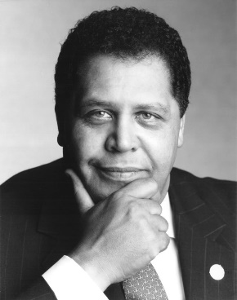
SS8H12 Explain the importance of developments in Georgia since the late 20th century.
a. Explain how the continued development of Atlanta under mayors Maynard Jackson and Andrew Young impacted the state.

Maynard Jackson (1938-2003) was the first African-American mayor of a major southern city. In 1968, Jackson e moved to Georgia and ran against Herman Talmadge for the U.S. Senate where he lost handily. However, he won the majority of votes from the city of Atlanta and became a force to be reckoned with in Atlanta’s politics. The next year, he became vice-mayor of Atlanta, and four years later, was elected mayor. He was only 35 years old at the time of his election.
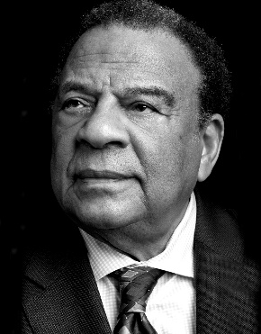
Serving as mayor of Atlanta from 1973-1981 and again from 1990-1994, Jackson was instrumental in providing more contract work to black-owned businesses and expanding Hartsfield Atlanta International Airport. He also sought to add more African American police officers to the city’s police force and to make sure that more African-Americans were promoted in the department. Jackson encouraged Atlanta to become a financial center and distribution hub for the southeast. He improved city housing and social conditions through Affirmative Action programs. Jackson also improved the mass transit system, making it one of the most modern in the United States. During his term in the 1990’s, he worked closely with Andrew Young to bring the Olympics to the city.
Andrew Young (b. 1932) Young was active in the Civil Rights Movement and primarily focused on voter registration drives. In 1961, Young started working for the SCLC. Young soon became a close associate with Martin Luther King, Jr. During his time at the SCLC, he successfully organized demonstrations and voter registration campaigns throughout the South. He was with Martin Luther King, Jr. on the day he was assassinated.
Young returned to politics and was elected mayor of Atlanta in 1981. His accomplishments as the mayor of Atlanta included bringing $70 billion in new private investment to the city of Atlanta, 1,100 new businesses and one million jobs to the region. He expanded programs for including minority and female-owned businesses in all city contracts. Young tripled college scholarships given to Atlanta public school graduates and was instrumental in overhauling and privatizing Zoo Atlanta and hosted the 1988 Democratic National Convention. After leaving office in 1989, Young continued to work for Georgia’s economic development, served as co-chair of Georgia’s 1996 Olympic committee, and worked as a consultant for many international organizations which he continues to do today.
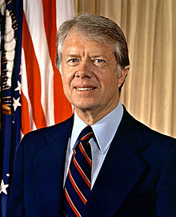
SS8H12 Explain the importance of developments in Georgia since the late 20th century.
b. Describe the role of Jimmy Carter in Georgia as state senator, governor, president and past president.

James Earl “Jimmy” Carter (b. 1924) was a state senator, governor, and the only person from Georgia to be elected president. He is also a winner of the Nobel Peace Prize and the second Georgian to win the award (Martin Luther King, Jr. was the first). Carter was a successful and popular governor, and his post presidential career has been arguably one of the most accomplished of any former president.

In 1962, he was elected to the state senate. As a state senator, Carter advocated for education and served as the chairman of the Senate Education Committee. He was, however, re-elected to the State Senate for a second term in 1964.
By 1966, Carter was interested in running for governor. By 1970, he again ran for governor and this time was elected. As governor, Carter is most well-known for his reorganization of state government and his consolidation of state agencies. In addition, he focused on improving Georgia’s educational, justice, and mental health systems. Carter also appointed more women and minorities to governmental positions than all of Georgia’s previous governors combined.
After his four-year term as governor was complete, Carter began to set his sights on a presidential run. Due to primary successes, Carter received the Democratic nomination for president and narrowly defeated President Ford in the 1976 election. His achievements include the Camp David Peace Accords between Egypt and Israel and the Strategic Arms Limitation Treaty (SALT II) with the Soviet Union. His disappointments include his decision to boycott the 1980 Olympics based on the Soviet invasion of Afghanistan, his management of the Iranian Hostage Crisis (the 1979 seizure of 52 American hostages by Iranian students who were held for 444 days), and the overall perception that he did not do enough to remedy the “stagflation” (persistent inflation and a stagnant economy) that was crippling the U.S. economy. After losing the 1980 presidential election, Carter returned to Georgia where he founded the Carter Center. The Center has monitored elections, resolved conflicts, and treated diseases world-wide. Domestically, Carter has supported and increased awareness of the Habitat for Humanity program. Carter has also written several books and was inducted to the Georgia Writers Hall of Fame in 2006.

In 1990, it was announced that Atlanta “finally won something” and was chosen as the host of the 1996 Olympic Games. Not since the International Cotton Expositions had Atlanta hosted such a large event. Beating the odds-on favorite Athens, Greece, to host the games, Atlanta began to prepare to for this important international event. In order to be ready, the city built new or added to existing sports venues, repaired its sidewalks, built public parks, added more hotel rooms, and revitalized the downtown area with new homes and apartments.
SS8H12 Explain the importance of developments in Georgia since the late 20th century.
c. Evaluate the short-term and long-term impacts of hosting the 1996 Olympics on Georgia’s economic and population growth.

The short-term impacts of the Olympic Games in Atlanta included the removal of the urban decay that downtown Atlanta was experiencing. The creation of Centennial Olympic Park led to the development of the area to include new apartments, hotels and business structures. Infrastructure developments, such as roadway improvements, the addition of sidewalks, and streetlights to name a few, brought people into the city for the games. The general clean-up of the city benefitted the local economy as people desired to visit and enjoy the games and food establishments and hotels. The improvements also created interest in developing new attractions such as the Georgia Aquarium. International recognition of Atlanta as a progressive city encouraged international economic status.
The long-term impacts have benefitted Atlanta itself. Due to the games the number of hotel rooms in the city expanded to over 60,000. The Olympics gave Atlanta international name recognition with the city showing that it was capable of hosting such a major event and being the home of the busiest airport in the world, Atlanta has become a hub for conventions and sporting events. The city also experienced growth for the first time in many years as many young, urban professionals moved from the suburbs to city limits based on their experiences at the games, and the improvements made to the city in preparation. The population of the city increased dramatically from 3.5 million in 1996 to 5.5 million in 2011. According to the New Georgia Encyclopedia, the Games have generated 5.1 billion dollars for the city and state. Increased population and has led to a declining housing market and increased traffic concerns. Positive economic impacts remain in parts of Atlanta, however, some neighborhoods that were neglected during the Olympic preparation period, remain blighted.

Tourism in Georgia has become one of the state’s largest industries. Because of the great geographic diversity in the state, over 100 million visitors traveled to Georgia’s mountains, beaches and major cities with unique attractions. With Atlanta as the top destination and Savannah and the Georgia coast following close behind, these cities and regions provide job opportunities for community members. Tourism has become the fifth largest employer in the state with revenues in the neighborhood of $59 billion providing 439,000 jobs. In 2016, the tourism industry generated $3 billion in direct and indirect taxes. The tourism industry employed 10.2% of Georgia’s workforce in 2016. One third of the tourists visiting Georgia were Georgians who enjoyed overnight stays at regional attractions.
SS8H12 Explain the importance of developments in Georgia since the late 20th century.
d. Analyze Georgia’s role in the national and global economy of the 21st Century, with regard to tourism, Savannah port expansion, and the film industry.

The Savannah Harbor Expansion Project (SHEP) is finally under construction after a 15-year study to determine the impact on the economy of Georgia and the nation. Savannah’s port is the fourth-busiest container port in the U. S. and is the fastest growing port. According to the Ports Authority, Savannah handles more than “3 million twenty-foot equivalent container units per year for more than 21,000 U. S. businesses.” American businesses ship products from this critical port in their supply chains. The Savannah Harbor Expansion Project will support jobs throughout the nation. Its economic impact on Georgia’s deep-water ports generates $67 billion in revenue. More than 350,000 jobs will be impacted and about $18.5 billion in personal income will impact the region. The impact of SHEP will help manufacturers on the national and global horizon.
Georgia’s film industry is rapidly becoming a major player in the industry. Due to encouraging financial incentives, the diversity of locations for filming, and growing production resources and professional support, Georgia is the destination in the southeast for film production. The moderate climate allows for year-round production and the airport in Atlanta provides for quick transportation for members of the industry. Since its creation in 1973 by then-governor Jimmy Carter, the Georgia Film Commission has grown to rank third behind California and New York. With a $7 billion economic impact in 2016, Georgia’s film industry is likely to continue to grow. Twenty-five thousand people in Georgia are directly involved in the industry and 30,000 people benefit through industries and businesses that are indirectly related. The Georgia Film Academy and colleges and universities, including the Savannah College of Arts and Design (SCAD), will help fill the projected 3,500 - 5,500 job opportunities by 2021. Tyler Perry, producer and actor, is currently converting the former Fort McPherson location into one of the largest film studios in the United States. With 800 film and television projects since 1972, Georgia’s film industry is likely to continue to grow.

