In 1954, Georgia’s response to the Supreme Court decision in Brown v. Board of Education (9 - 0 decision that racial segregation violated the 14th Amendment) was deliberate and extreme. Georgia schools would not integrate. The Georgia General Assembly supported “massive resistance” (white opposition to court ordered desegregation) and maintained a strong opposition to the forced integration of public schools. By 1960, however, federal mandates were strongly encouraging Georgia to desegregate, and Governor Ernest Vandiver asked the citizens of the state to render their input regarding the controversy via the Sibley Commission.
SS8H11 Evaluate the role of Georgia in the modern civil rights movement.
a. Explain Georgia’s response to Brown v. Board of Education including the 1956 flag and the Sibley Commission.

John Sibley, a segregationist lawyer who also believed resistance to federal mandates was useless, led ten hearings across the state to determine if the people felt that they should continue to resist the federal government or change laws to integrate schools (Sibley wanted laws that would allow integration on a very small scale). After the sessions, 60% of Georgians claimed that they would rather close the public schools than to integrate.
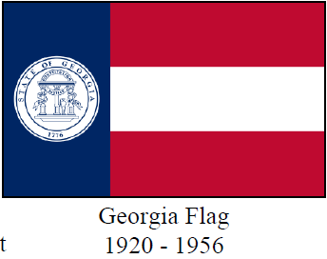
Despite the findings, Sibley pushed for schools in Georgia to desegregate on a limited basis. Based on the commission’s findings, the legislature was set to vote on the matter in January 1961, but the integration of the University of Georgia shifted the governor’s and the legislature’s focus. After attempting to close the University of Georgia, only to be overruled by a federal judge, Gov. Earnest Vandiver gave in and asked the General Assembly to accept Sibley’s recommendations. Later that year, the city of Atlanta desegregated its schools.
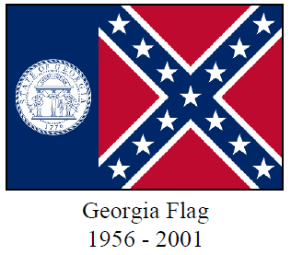
Meanwhile, in an attempt to show disdain to Supreme Court decisions such as Brown v Board of Education, in 1956, Georgia’s legislators voted to change the state flag to incorporate the Confederate battle flag. The state constitution provided the legislature the sole authority to change the flag so no public referendum was necessary to make the change. While legislators denied that the change in flag design was an overt display of opposition to desegregation, the new flag design was almost certainly racially motivated.
During the height of the civil rights movement in the late 1960’s, suggestions to return to the pre-1956 flag were stirring. Controversy over the flag continued through the 1996 Atlanta Olympic Games. However, Atlanta business leaders were unable to persuade the General Assembly to change the flag.
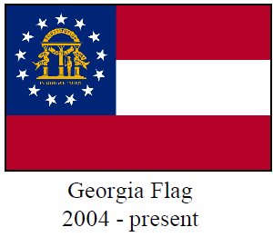
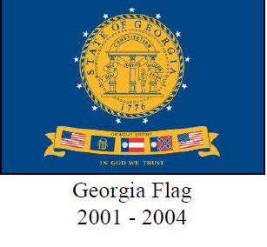
Finally, Governor Roy Barnes attempted to put the issue of the 1956 flag to rest. Barnes encouraged the legislature to pass HB 16. After it was passed and the new flag design was revealed, supporters of the 1956 flag were livid, with some calling the new flag the “Barnes Rag”. With the upset victory of Sonny Perdue over Barnes in 2002, the flag issue continued to be debated. By 2004, citizens of Georgia voted to choose the current state flag over the Barnes flag.
SS8H11 Evaluate the role of Georgia in the modern civil rights movement.
b. Describe the role of individuals (Martin Luther King, Jr. and John Lewis), groups (SNCC and SCLC) and, events (Albany Movement and March on Washington) in the Civil Rights Movement.

Dr. Martin Luther King, Jr. (1929-1968) is the most well-known Georgian for his tireless leadership in the Civil Rights Movement. His work and his devotion to non-violent protest earned him the Nobel Peace Prize and led to the national holiday created in his honor.
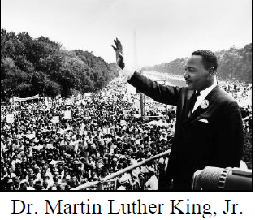
Born in Atlanta, King graduated from high school at the age of 15, and began his college studies at Morehouse College, a historically black institution of higher learning. As the son and grandson of ministers, King eventually chose the same profession. He earned his Ph.D. in Divinity from Boston University. It was there that he met his wife Coretta Scott.
In 1954, King accepted an offer to become the pastor of Dexter Avenue Baptist Church in Montgomery, Alabama. A year later, he found himself serving as the spokesperson for the successful Montgomery Bus Boycott. When Alabama prosecuted King for violating the state's anti-boycotting statute, his attorneys transformed a hostile courtroom into an empowering forum. Eventually, the Supreme Court made segregation on Montgomery busses unconstitutional. After the successful boycott, King, along with other civil rights groups, attempted a similar action in Albany, Georgia that was considered to be less successful. His creation of the Southern Christian Leadership Conference (SCLC), the March on Washington, his voter registration campaign in Selma, Alabama (which ultimately led to the Voting Rights Act of 1965), and winning the Nobel Peace Prize. However, these victories were followed by unsuccessful campaigns such as his focus on discrimination in Chicago, Illinois.
The Southern Christian Leadership Conference (SCLC) was created in 1957 in Montgomery, Alabama in reaction to the Montgomery Bus Boycott. Led by Dr. Martin Luther King, Jr., who was living in Montgomery at the time, the organization eventually was supported by Southern religious leaders. The headquarters for the SCLC was moved to Atlanta. Filing class-action law suits against the federal government for sustaining segregated employee cafeterias, the SCLC planned rallies, marches, and boycotts to end such scenarios. The SCLC organized protests (the Albany Movement) and opportunities for the economic improvement of African-Americans throughout the South. Though active throughout the Civil Right Movement, the SCLC continues to strive to change and impact lives. Never forgetting its original goal of civil rights equality, the SCLC today focuses on causes such as health care, prison reform, fair treatment of refugees, and job site safety.
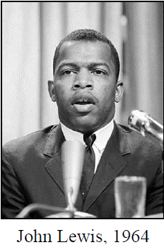
U. S. Representative John Lewis (b. 1940), born to sharecroppers in Pike County, Alabama, Lewis became an integral part of Georgia’s history through his leadership in the Civil Rights Movement. Active in the 1960’s sit-ins to protest Jim Crow laws, Lewis also participated in the Freedom Rides of the early 1960’s. He became the chair of the new organization, the Student Nonviolent Coordinating Committee (SNCC - pronounced “snick”), an Atlanta-based organization of young college students devoted to civil rights change. With Dr. King, Lewis was a keynote speaker at the 1963 March on Washington for Jobs and Freedom. In 1965, Lewis also led over 600 marchers across the Edmund Pettus Bridge in Selma, Alabama only to be beaten by Alabama state troopers. Television coverage of this “Bloody Sunday” event brought much needed attention to the Civil Rights Movement.
In the late 1960’s and 70’s, Lewis continued his dedication to seeking civil rights through voter registration and volunteer programs. Elected to the Atlanta City Council in 1981, he advocated for ethics in government and community preservation. In November 1986, Lewis was elected to the United States Congress from the Fifth Congressional District where he continues to serve today. Lewis has won numerous awards through the years that reflect his dedication to seeking civil rights for all. He has co-authored MARCH, a trilogy of graphic novels for young people to help explain the Civil Rights Movement.
The Student Nonviolent Coordinating Committee (SNCC - pronounced “snick”) was an important element in the struggle for civil rights. The SNCC was one of the major civil rights organizations of the 1960’s. A national organization formed in North Carolina, it worked with the Southern Leadership Conference and focused on orchestrating peaceful, non-violent protest. The group, made up of high school and college-aged students, became known for sit-ins, freedom rides, and the “freedom summer” in Mississippi.
In Georgia, the group began its focus on the cities of Albany and Atlanta. In Albany, the group was at the forefront of the Albany Movement, which many considered to be unsuccessful. However, the Albany Movement was beneficial in helping the group later organize more successful protests. In Atlanta, the group organized successful sit-ins in 1960.
The Albany Movement. After the success of the Montgomery Bus Boycott in 1955, civil rights leaders in other southern cities sought to challenge segregation laws. One of the cities selected was Albany, in southwest Georgia. Starting in the fall of 1961, members of SNCC and the local community began to protest the segregationist policies of the city. Massive resistance from whites and the police department led to over 500 protesters landing in jail. However, unlike Montgomery, many of Albany’s black middle class did not initially support the protests. In turn, police Chief Laurie Pritchett used non-violent tactics to arrest, but not harm the protestors.
To draw more national attention to the cause, the SNCC invited Martin Luther King, Jr. to take part in the protest. Though arrested many times, King was released from jail almost immediately (though against his will). Chief Pritchett also made sure he had enough room to imprison all the protestors and worked with other counties to send the demonstrators to their jails as well. In the end, most of the protestors were jailed leaving very few to protest.
By the summer of 1962, King viewed the Albany Movement as a failed attempt to desegregate an entire community, but a valuable learning experience. However, the African-American citizens of Albany believed that they had accomplished much. According to the New Georgia Encyclopedia, after King and the members of SNCC left the city, black voter registration led to a run-off election for an African-American nominee for a county commission seat. More importantly, the next spring the “county commission removed all segregation statutes from their books.”
The March on Washington. In 1963, over 250,000 civil rights activists gathered in Washington D.C. to promote their cause and push for civil rights legislation. During the March on Washington for Jobs and Freedom, Martin Luther King, Jr. gave what is arguably his most famous speech: “I Have a Dream.” The March on Washington encouraged the passage of the Civil Rights Acts of 1964 and The Voting Rights Act of 1965, and made King the most well-known spokesperson of the Civil Rights Movement.
Throughout the 1960’s, civil rights activists for the Student Non-Violent Coordinating Committee (SNCC) and the Southern Christian Leadership Conference (SCLC) continued to target Georgia. In 1963, Savannah became one of the most integrated cities in the South, due to the efforts of the National Association for the Advancement of Colored People

(NAACP). Soon after, Atlanta Mayor Ivan Allan, Jr., Coca-Cola president Robert Woodruff, and other business leaders, worked with civil rights leaders to ensure that Atlanta desegregated peacefully.
SS8H11 Evaluate the role of Georgia in the modern civil rights movement.
c. Explain the resistance to the 1964 Civil Rights Act, emphasizing the role of Lester Maddox.

Encouraged by the March on Washington, the U.S. Congress passed the Civil Rights Act of 1964. This bill was signed into law by President Lyndon B. Johnson. The Civil Rights Act of 1964 forbade discrimination on the basis of sex and race in hiring, promoting, and firing.
Southern Congressional Democrats, led by Senator Richard Russell, strongly opposed the passage of the legislation. Some segregationists were determined to ignore the new law and responded with physical violence. However, most southerners accepted the controversial passage of the Civil Rights Act of 1964. It was during this period of great social and political change in Georgia that future governor, Lester Maddox (1915-2003), gained notoriety for his strong, unshakeable segregationist stand.
Born in Atlanta in 1915, Maddox dropped out of high school and he worked several jobs, including the Bell Bomber factory during World War II. In 1947, he opened the Pickrick Cafeteria near the campus of Georgia Tech. Open only to white customers, Maddox refused to serve African-Americans and anyone who suggested integration. His restaurant featured segregationist literature and a wishing well labeled “Make a Wish for Segregation.” He gained fame throughout Georgia due to his advertisements for the restaurant that he placed in the Atlanta Journal newspaper.
In 1966, Maddox surprised many by beating Ellis Arnall for Governor in the Democratic primary. As the last overtly segregationist governor in the state’s history, ironically, Maddox appointed more African-Americans to government positions than all prior Georgia governors combined. Nonetheless, Maddox was criticized for not allowing flags at state buildings to be flown at half-mast after the death of Martin Luther King, Jr., and for his fight against the civil rights platform of the Democratic Party at their 1968 National Convention. After his term as Governor was over, due to constitutional term limits, Maddox ran for Lieutenant Governor. As Governor Jimmy Carter’s Lieutenant Governor, he often clashed with Carter over many issues.
Maddox ran for governor again in 1974 but was defeated. He also ran for U. S. president in 1976. After retiring from politics, he operated several other businesses, but none were as profitable as the Pickrick Cafeteria. Throughout his life, he never apologized for his defense of segregation. Maddox died of cancer at the age of 87.

