CIVICS / GOVERNMENT SS8CG1abcde NAME: ______________________________
SS8CG1a Explain the basic structure of the Georgia state constitution.
1. What is the preamble? Identify the differences between the Georgia Constitution Preamble and the U.S. Constitution Preamble?

2. What are the Bill of Rights? Identify the location of the Bill of Rights in the U.S Constitution, and the Georgia Constitution. Explain why the Bill of Rights is important to you?

3. Which Articles describe the three branches of government?

4. What are amendments and how are they ratified?
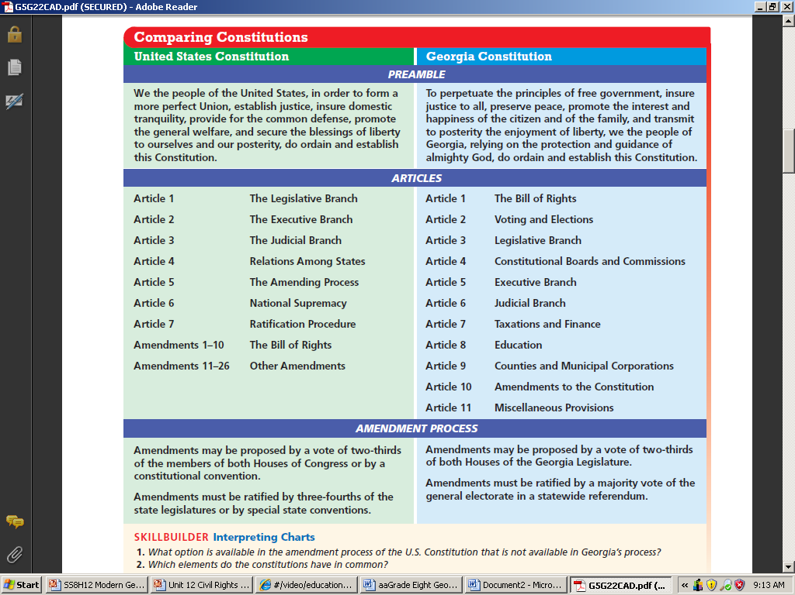

SS8CG1b Explain the concepts of separation of powers and checks and balances.

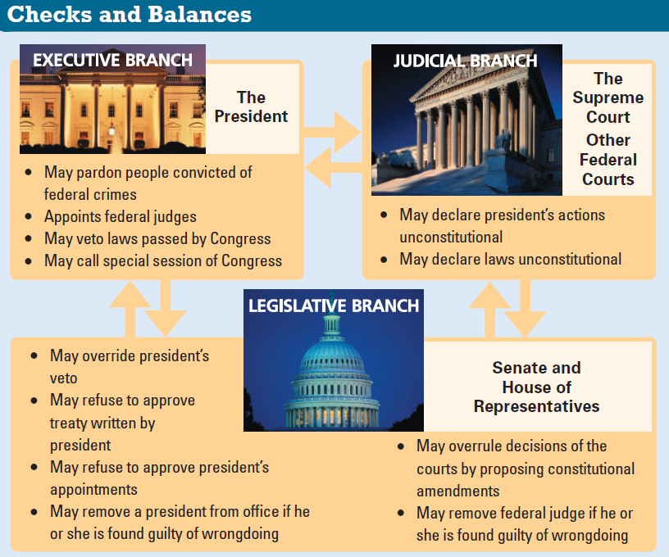
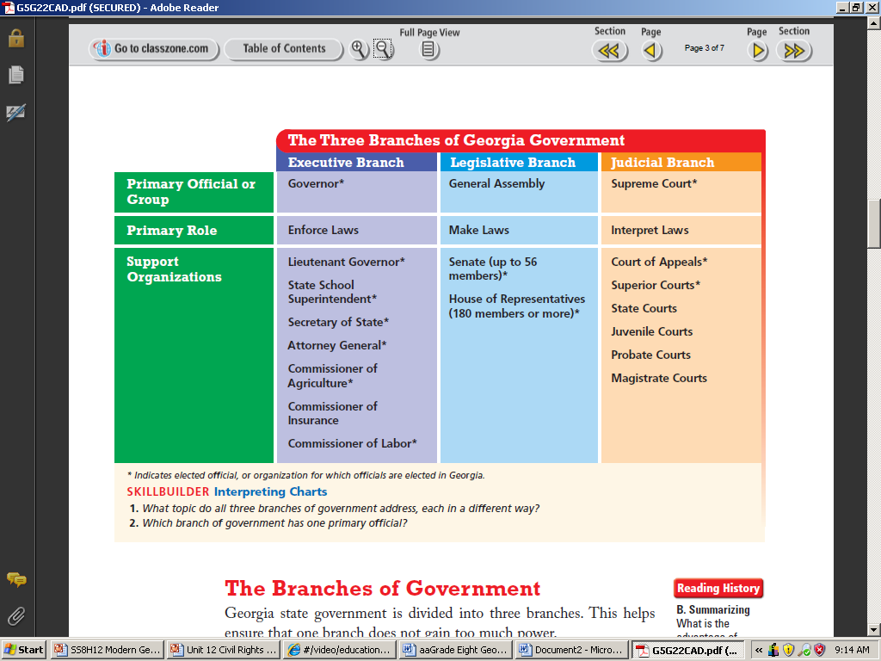

6. Analyze the chart above, and explain the purpose of Checks and Balances between all three branches?
5. Analyze the chart above, and explain how does the separate branches of government ensure equal power among the branches?

SS8CG1c Describe the rights and responsibilities of citizens.
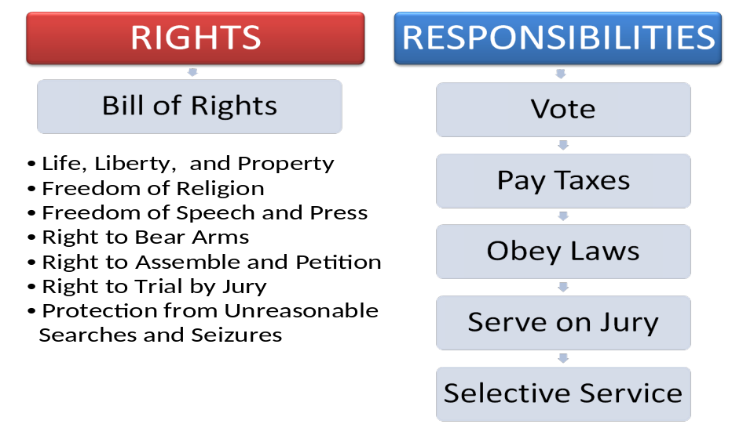
7. As a citizen of Georgia and the United States, which of the Rights do you value the most? Why?

8. What types of actions do you believe could takes these rights away?

9. Pick one responsibility and describe why it is important.

SS8CG1d Explain voting qualifications and elections in Georgia.
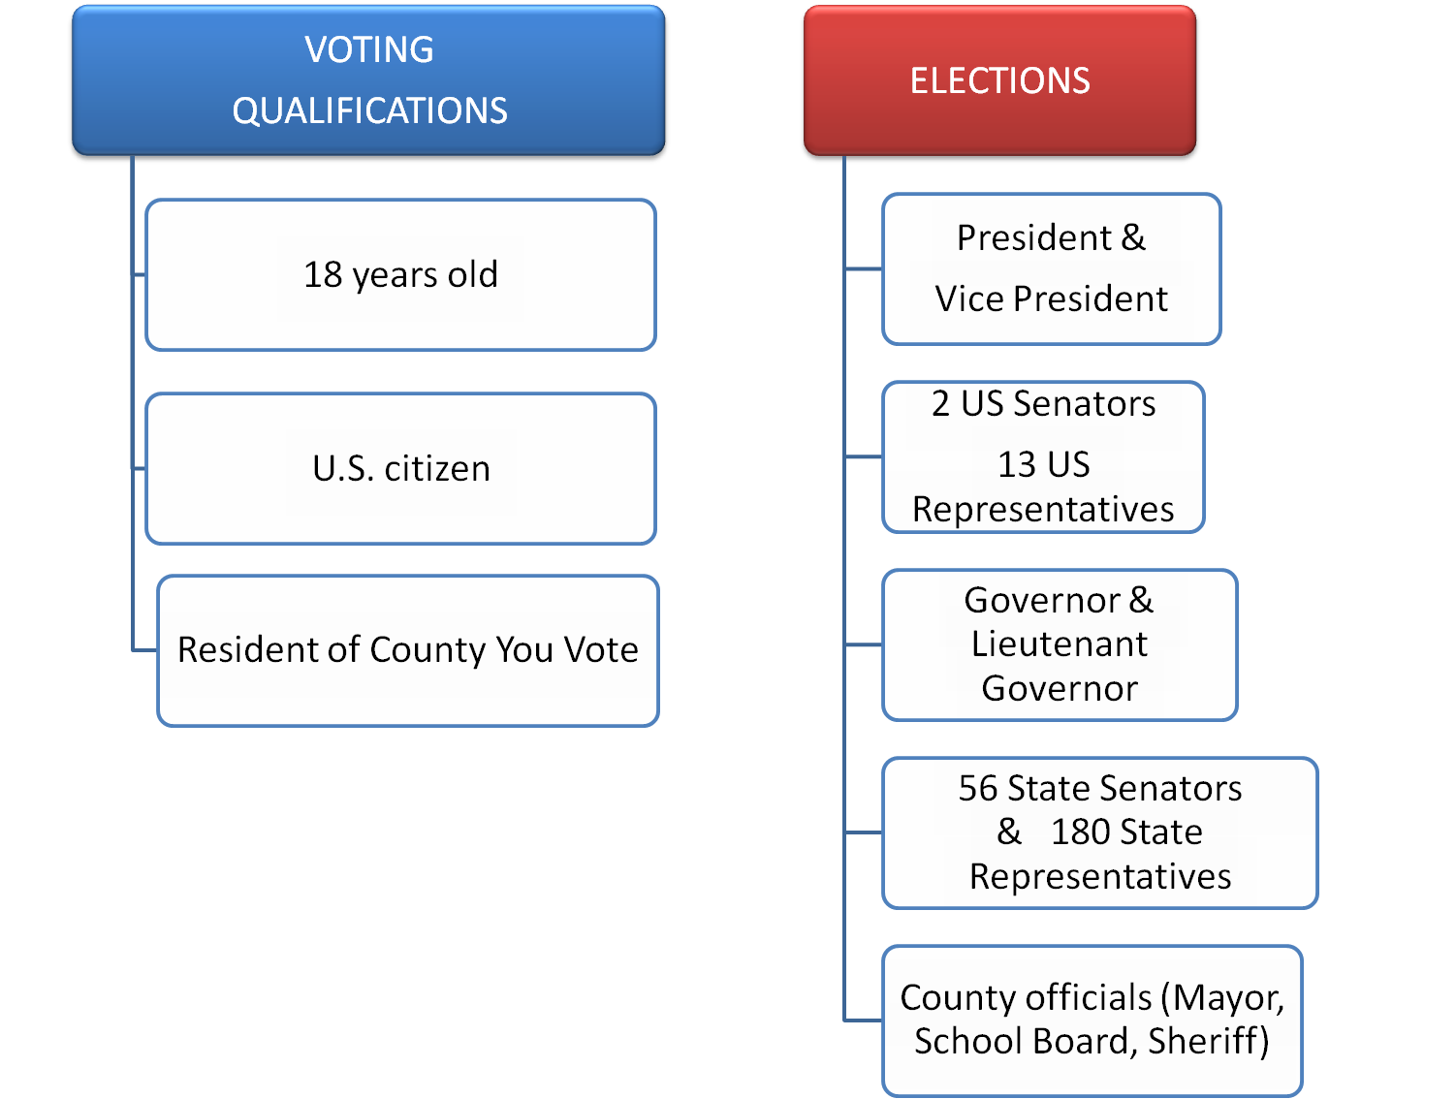
Primary (1st) Election
People vote for political party candidate in July. There’s a Democrat Primary and a
Republican Primary.
10. Who gets to vote in the State of Georgia?

11. Describe the types of elections in the State of Georgia

12. How many U.S Senators & U.S. Representatives and State Senators and State Representatives do Georgians get to vote for?

13. Describe the difference between a primary election and a general election.

General Election
Democrat, Republican, and other party primary winners compete against each other to win the general election. Voting is in November. Popular vote wins election.


SS8CG1e Identify wisdom, justice, and moderation as the three principles in the Pledge of Allegiance to the Georgia Flag.

Adopted on March 28, 1935 by Governor Eugene Talmadge

“I pledge allegiance to the Georgia flag and to the principles for which it stands; – wisdom, justice & moderation”

Georgia’s current flag was adopted in 2008; Consisting of 3 stripes of red, white, red, a blue canton containing a ring of 13 stars encompassing the state's coat of arms in gold. The coat of arms consists of an arch that symbolizes the state constitution & three pillars representing the
Legislative, judicial & executive branches. The words “wisdom,” “justice,” & “moderation” are wrapped around the pillars.
Why these 3 words?
Wisdom: reminds the legislature to be wise in creating laws
Justice: appeals to the judicial branch for fair and just decisions
Moderation: urges the executive branch to carry out laws calmly within the boundaries of the law
14. In your own words, define wisdom, justice, and moderation. What do these words mean to you?

15. Create your own pledge. This can be a pledge to your family, your school, or your future self.

