Paleo Indian Period vs.
Mississippian Period

Paleo-Indian Period
Part I – Reading Article: Paleo Indian Period: Overview- The New Georgia Encyclopedia
http://www.georgiaencyclopedia.org/articles/history-archaeology/paleoindian-period-overview

Historical Background
The initial human settlement of Georgia took place during one of the most dramatic periods of climate change in recent earth history, toward the end of the Ice Age. Exactly when human beings first arrived is currently unknown, although people had to have been present 13,250 years ago: distinctive artifacts of the Clovis culture (so named from the New Mexico town of Clovis, where the characteristic stone projectile points with a central groove were first unearthed) have been found at a number of locations across the state. The late glacial southeastern environment these first peoples encountered was markedly different from today's environment. Sea levels were more than 200 feet lower than present levels, and the Atlantic Ocean and Gulf of Mexico shorelines were 100 or more miles seaward of their present locations. Global temperature was rising rapidly during the interval from 15,000 to 11,000 years ago, and the great continental ice sheets were retreating, causing the coastline to move rapidly inland.
During this interval massive extinctions of such animals as elephants, horses, camels, and other megafauna took place, and vegetational communities shifted location and composition in dramatic fashion.
Chronology
Paleo Indian occupations in Georgia occurred approximately 10000-8000 B.C. People may have been present before the Paleo-Indian period, but identifiable remains have not been found in the state. Archaeologists recognize sites primarily by the presence of projectile points found (weapons that were capable of being thrown or projected, such as a spear, dart, or arrow, or perhaps used as a knife). The Paleo-Indian is characterized by a Clovis, relatively large (lance-shaped) heavy, leaf-shaped stone spearhead.
Way of Life
Most likely, Paleo-Indians moved over large areas, on foot or by water, in small bands of twenty-five to fifty people. Although it is known they were hunter-gatherers, it is not known whether their diet primarily consisted of large game animals or a wide array of plant and animal species.
Paleo-Indian groups are thought to have lived in central base camps for varying lengths of time. Once local resources were exhausted, they relocated to a new area, possibly quite some distance away. Several such moves may have occurred over the course of a year. Paleo-Indian toolkits were artifacts of chipped stone and carved bone—projectile points, scraping and engraving tools and cutting tools.
Over the course of the Paleo-Indian era, fixed base camps gave way to a more nomadic way of life, with people readily and repeatedly moving their camps as they exhausted the food supply in their immediate area.
Mississippian Period
Part I (cont.) – Reading Article: Mississippian Period- The New Georgia Encyclopedia
http://www.georgiaencyclopedia.org/articles/history-archaeology/mississippian-period-overview
Mississippian people, who were mainly farmers, often lived close to rivers, where periodic flooding replenished the nutrients in the soil and kept their gardens productive. They lived in small villages that rarely had more than a few hundred residents and in some areas also lived in single-family farms. Although there was a great deal of variation across Georgia, a typical Mississippian village consisted of a central courtyard, residential area, and defensive structures.
The courtyard, located in the center of the town, served as a gathering place for many purposes, from religious to social. Houses were built around the courtyard. Some, though not all, Mississippian villages also had defensive structures. Usually these took the form of a pole wall, known as a palisade; sometimes there was a ditch immediately outside the wall (moat). These helped to keep unwelcome people and animals from entering the village.
Some Mississippian towns featured mounds. These were made from locally quarried soil and could stand as tall as 100 feet. Most were built in stages, sometimes over the course of a century or more. Although Mississippian mounds were made in various shapes, most were rectangular to oval and flat-topped. These mounds were used for a variety of purposes: as platforms for buildings, as stages for religious ceremonies, and as cemeteries. Only chiefs built their houses and placed temples to their ancestors on mounds, conducted rituals from the summits of mounds, and buried their ancestors within mounds.
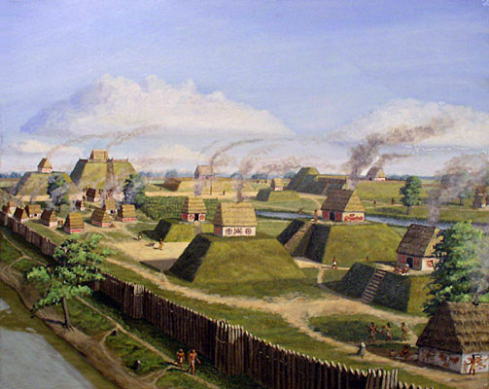
A village during the Mississippian Period

Paleo Indian Period vs. Mississippian Period – Written Response
Part II Directions: Complete the following written response to the readings on the Paleo Indian Period vs. Mississippian Indians. Be sure to answer the questions in complete sentences and cite text evidence (specific examples from the text) that supports your argument.

Prompt #1 – Discuss how the Paleo Indian Period and the Mississippian Indian settlements are similar. Explain ways using text evidence.
_______________________________________________________________________________________________________________________________________________________________________________________________________________________________________________________________________________________________________________________________________________________________________________________________________________________________________________________________________________________________________________________________________________________________________________________

Prompt #2 – Discuss how the Paleo Indian Period and the Mississippian Indian settlements are different. Explain ways that they are each uniquely different. Provide text evidence. _______________________________________________________________________________________________________________________________________________________________________________________________________________________________________________________________________________________________________________________________________________________________________________________________________________________________________________________________________________________________________________________________________________________________________________________

Prompt #3 – After examining the readings, describe the technological advancements from the Paleo to the Mississippian period.
__________________________________________________________________________________________________________________________________________________________________________________________________________________________________________________________________________________________________________________________________________________________________________________________

