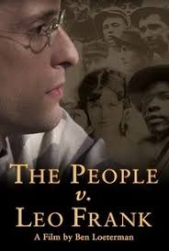
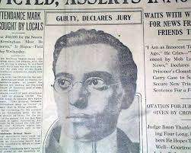
Name: __________________________
The New South and Leo Frank
As you watch the program, answer the following questions in the space provided.

- Who were the four main characters involved in the murder at the National Pencil Factory?

- Describe Mary Phagan.

- When was Mary Phagan murdered? What was the name of the holiday on which she was murdered? Of what significance is this holiday?

- Who was the initial suspect in the case?

- What evidence suggests that the Atlanta police were under a lot of pressure to identify and charge a suspect with the crime?

- Who were the Pinkerton agents, and why were they brought into the murder investigation?

- Analyze the murder notes found at the scene. What is the significance of phrases like "night witch" and "long, slim, tall Negro"?

- When did the murder trial begin, and how long did it last?

- Who was the judge who sentenced Leo Frank to die? Did he support the jury's verdict?

- What was the date and time of day that Leo Frank was kidnapped from the prison farm, and when was he lynched?

- From which prison building did the kidnappers take Frank, and why was Frank residing in this particular building at the time?

