*STANDARD: SS8H4 Explain significant factors that affected westward expansion in Georgia between 1789 and 1840.*

*b. Evaluate the impact of land policies pursued by Georgia; include the headright system, land lotteries, and the Yazoo Land Fraud.*

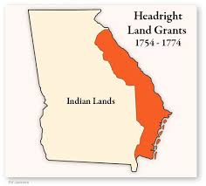The first approach employed was called the **headright system**. By 1783, under this system, Georgia gave thousands of acres of land to soldiers who had fought during the Revolution. Under this system, men who did not fight in the Revolution could also receive free land. Heads of households (white men over the age of 21) could receive up 200 acres of land, plus

50 acres per family member (including slaves), up to a limit of 1000 acres!!!. Men who had families or slaves received even more. This system ended when there were too many claimants and not enough land to offer. It caused massive immigration to Georgia.

The second approach was called the **Yazoo Act** (1795) which was named after a river in the present state of Mississippi. This act sold much of the land that would become Alabama and Mississippi to four land companies for $500,000. Soon after Georgia governor George Mathews signed the Yazoo Act into law, it was discovered that the land companies bribed members of the Georgia General Assembly to sell them huge tracts of land for extremely low prices, so that they could sell it to others for profit. Sometimes they granted more land than existed. Almost immediately, Georgians protested the sale.

Nevertheless, the legislators chose to continue with the arrangement. Upon hearing about this, one of Georgia’s U.S. senators, James Jackson, was so outraged he resigned from his seat and returned to the state. Once back, he and his political allies took control of the Georgia General Assembly and nullified the Yazoo Act. In 1802, Georgia ceded the land to the U.S. government for $1.25 million dollars and the promise that the U.S. would relinquish Indian land claims in the state and remove the Creek Indians from Georgia. The controversy surrounding the Yazoo Act is known as the Yazoo Land Fraud which became the first major scandal in American history.

The “Burning of the Yazoo Act” at Louisville shows James Jackson and others standing around the Yazoo document set ablaze. It is said that they used a magnifying glass to bring “fire from heaven” to destroy the act.

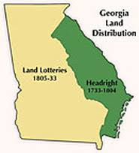The final approach Georgia used to allocate land was the **land lottery system**. From 1805-1833, Georgia had eight land lotteries. These lotteries gave the average Georgian the opportunity to gain a large amount of land for pennies on the dollar. To take part in a land lottery, a person would simply have to submit their names to the state and pay for a ticket. On the day of the lottery, the participants’ names were placed in one drum while the land lots bearing a number would be placed in a second drum. Participants could have their name placed in the drum more than once based on characteristics such as their age, marital status, and war service. The land lotteries gave three quarters of Georgia’s land to 100,000 families.

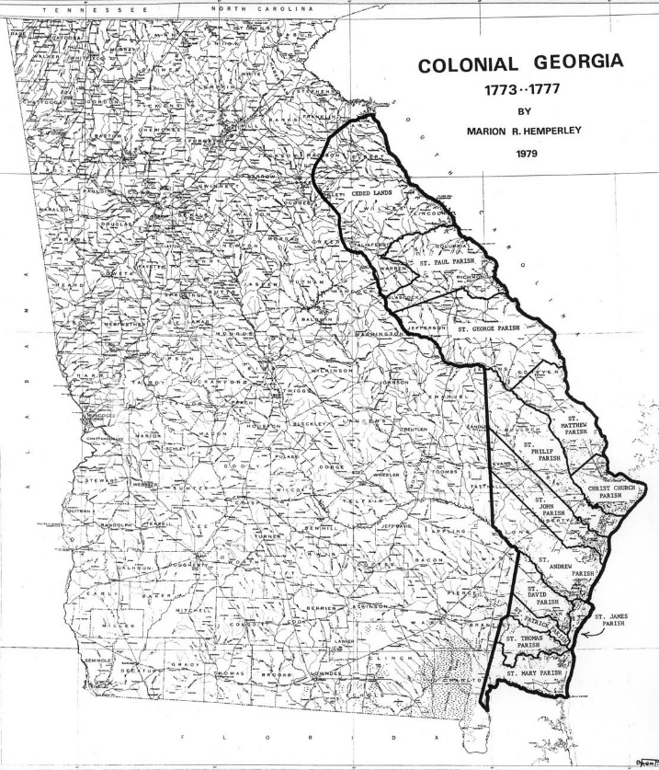

The map to the right shows the state of Georgia. The black outline on the map shows what was considered Georgia before the end of the Revolutionary War.

**Headright System**

Prior to 1803, Georgia distributed land using the Headright system.

1. How could someone get land under the **headright system?**

2. Who appears to be left out of this system?

3. Why did Georgia stop using this system?

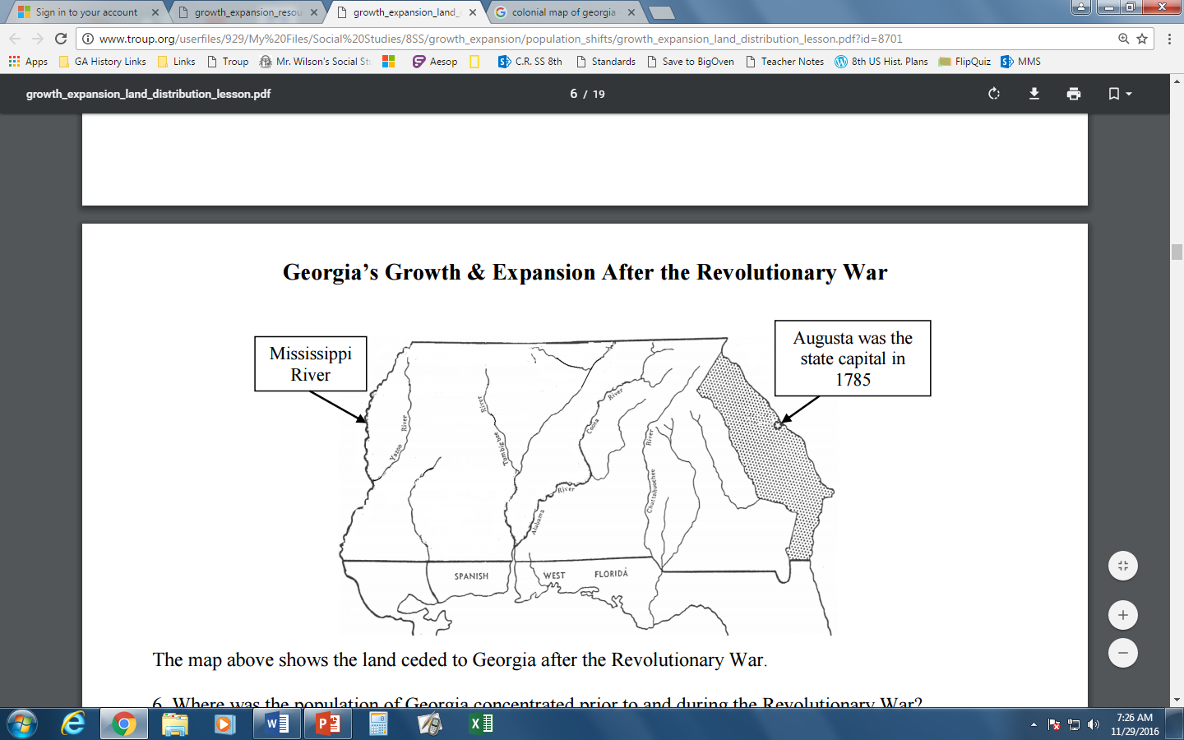

The map to the left shows land ceded to Georgia after the Revolutionary War.

4. Where was Georgia’s population concentrated prior to and during the Revolutionary War?

5. After the Revolutionary War, when Georgia gained more land, what type of population shifts do you think occurred? Why? _______________________________________________________________________________________

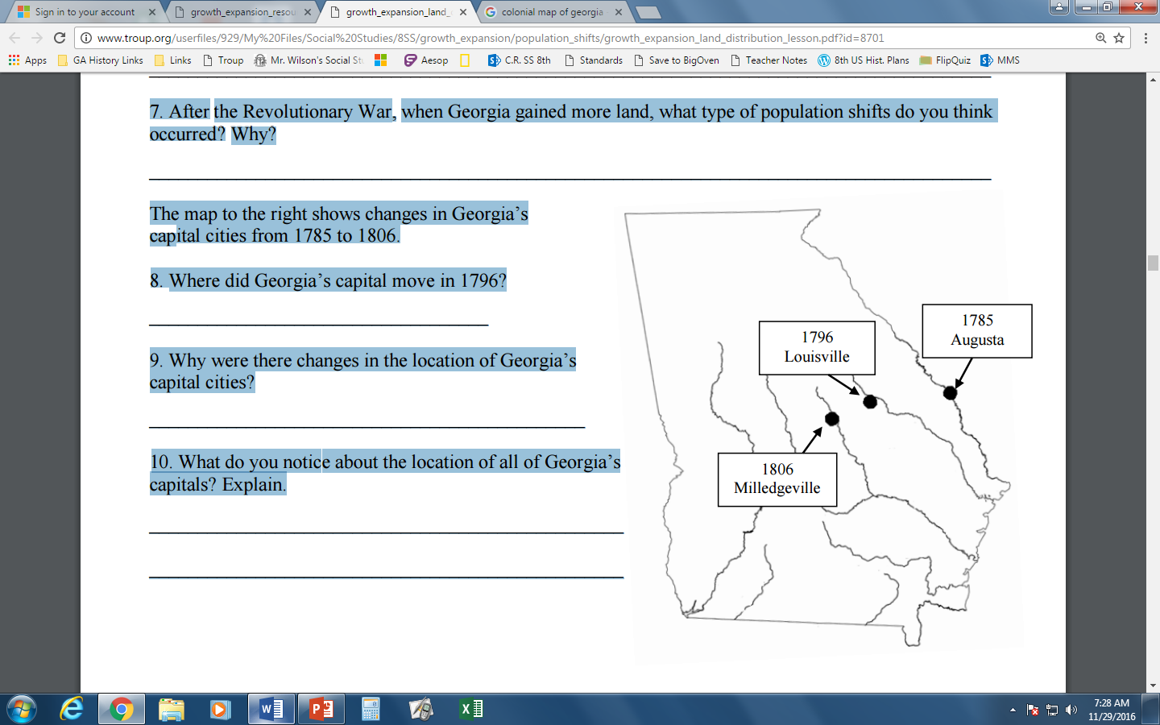The map to the right shows changes in Georgia’s capital cities from 1785 to 1806.

6. Where did Georgia’s capital move in 1796? ___________________________________

7. Why were there changes in the location of Georgia’s capital cities? ______________________________________________________

8. What do you notice about the location of all of Georgia’s capitals? Explain.

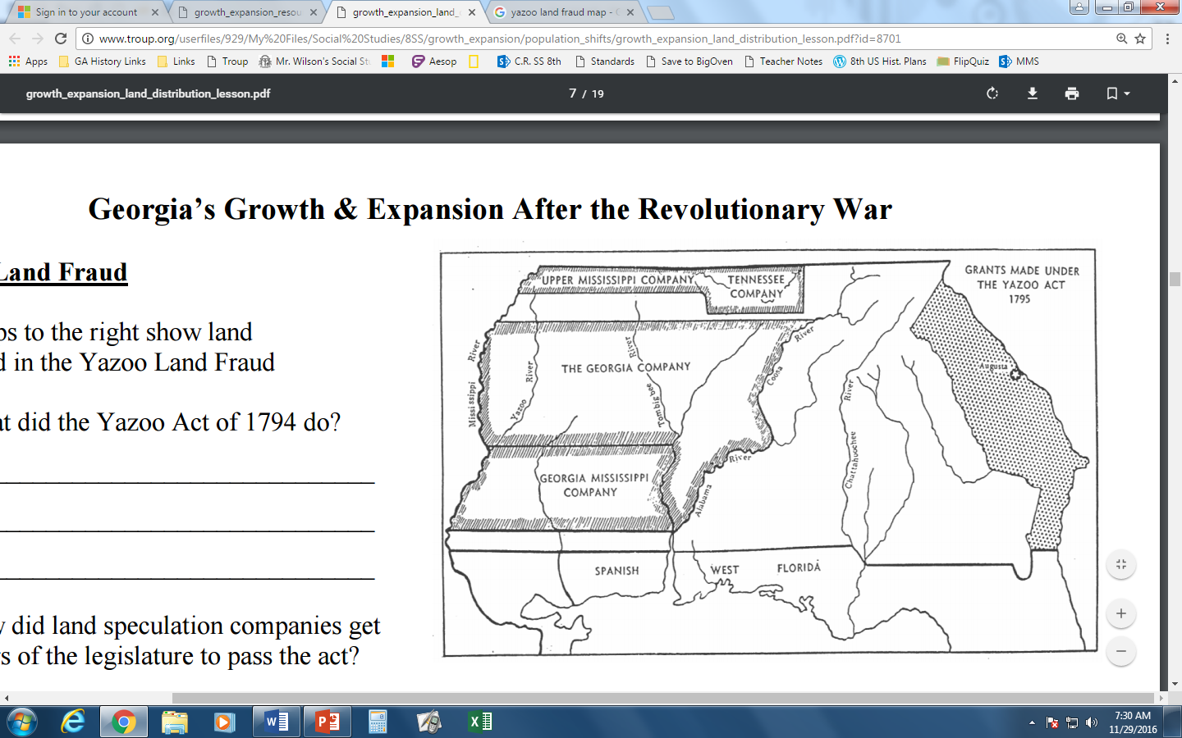**Yazoo Land Fraud**

The maps to the left show land involved in the Yazoo Land Fraud

9. What did the Yazoo Act of 1795 do?

10. How did land speculation companies get members of the legislature to pass the act?

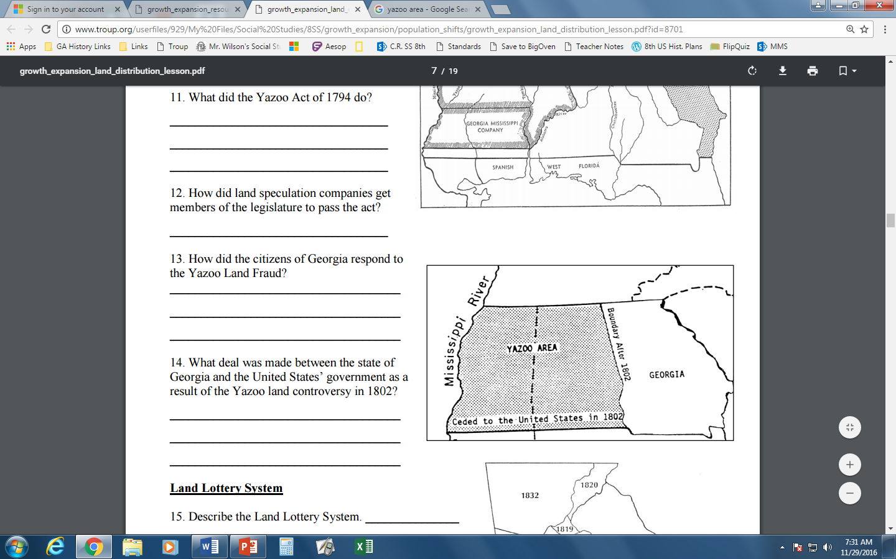11. How did the citizens of Georgia respond to the Yazoo Land Fraud?

12. What deal was made between the state of Georgia and the United States’ government as a result of the Yazoo land controversy in 1802?

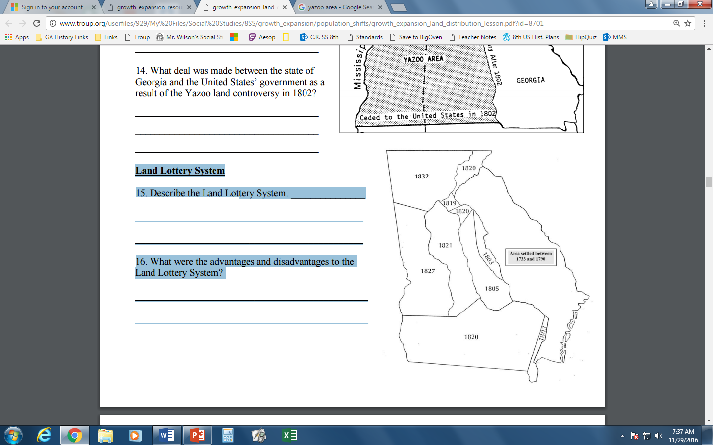**Land Lottery System**

13. Describe the Land Lottery System. __________________________________________________ ___________________________________________________

14. What were the advantages and disadvantages to the Land Lottery System? _______________________________________________ ______________________________________________________

**Essential Question**: In a complete paragraph, how did land obtainment lead to population shifts in Georgia?

a. What is meant in the essential question by the phrase “land obtainment”?

b. What is meant in the essential question by the phrase “population shifts”?