



1. What did Atlanta host to prove it was an important city in the South?

2. What was the law of the land?

3. Besides blacks, who did the KKK target during the New South period?

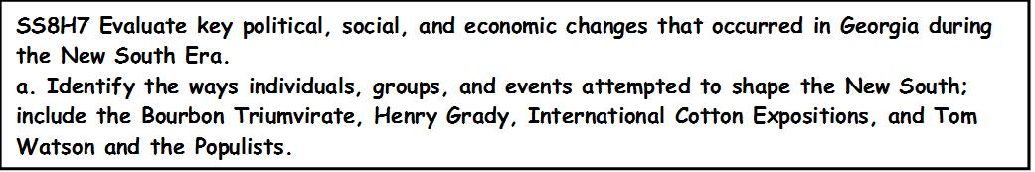

4. Which three politicians made up the Bourbon Triumvirate?

5. How long did the Bourbon Triumvirate rotate positions in government?

6. What type of common interests did the Bourbon Triumvirate have?

7. Describe the convict lease system?

8. Why did the power of the Bourbon Triumvirate disappear?

9. Compare the following three individuals of the Bourbon Triumvirate. Include their views and accomplishments.

|  |  |  |
| --- | --- | --- |
| **Brown** | **Colquitt** | **Gordon** |
|  |  |  |

**Henry Grady**

10. Henry Grady is best known for what?

11. List Henry Grady’s accomplishments

12. Who was a critic of Henry Grady and why?

13. Why did Henry Grady depict positive racial relations in the south?

**International Cotton Exposition**

14. Why was the Cotton Exposition established?

15. Why did Booker T. Washington gave give a speech at the Cotton States and International Exposition? What was the name of the speech? Who supported his views? Who did not support his views?

**Tom Watson and the Populist**

16. In Tom Watson’s early career, who did he support?

17. In 1892, he supported the end of what system?

18. How was Tom Watson elected to U.S Congress?

19. Watson gained notoriety for his leadership role in the passage of what Act?

20. What was the Rural Free Delivery Act?

21. Why did Watson receive the support of many rural black voters?

22. What did the Populist Party support?

23. By the end of Watson’s life, he changed his views on race, and targeted the following groups;

24. Many speculate that Watson’s articles in the Jeffersonian were responsible for the death of who?